**LAB REPORT NO 02**



**Computer organization and Architecture (CSE 304L)**

**Fall 2024**

**Submitted By: Naveed Ahmad**

**Registration No: 22PWCSE2165**

**Section: B**

Date: 02/12/2024

**Submitted To:**

**Dr. Ammad Khalil**

**Department of Computer Systems Engineering**

**University of Engineering and Technology**

**TAKS 1:**

Printing string using asciiz.

**CODE PIC:**

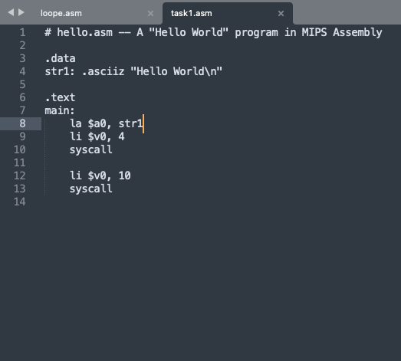

**OUTPUT PIC:**

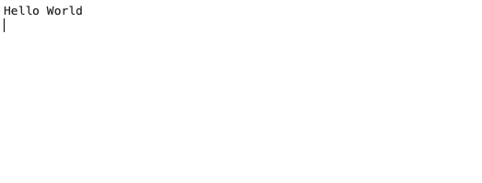

**TAKS 2:**

Printing Hello World using .byte hexadecimal.

**CODE PIC:**

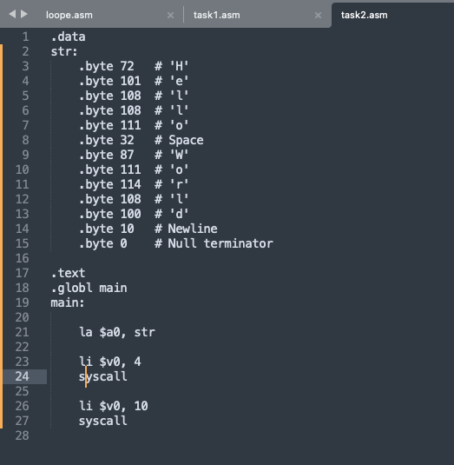

**OUTPUT PIC:**

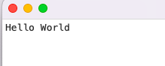

**TASK 3:**

Conditional Execution: the larger Program.

**CODE PIC:**

**OUTPUT PIC:**

**TASK 4:**

Looping: the *multiples* Program.

**CODE PIC:**

**OUTPUT PIC:**

